We’re Going on a Fruit Hunt… 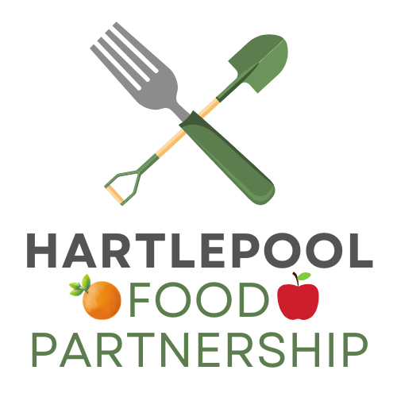 

Fruit |  | Have you… (TICK BOXES please…) |  | Do you  Like it?
 |  | Found it in a shop? | Tried it? | Do you  Like it?
Apple
Pear
Banana
Orange/Satsuma
Red Grapes
Green Grapes
Strawberry
Raspberry
Blackberry/Bramble
Blueberry
Pineapple
Watermelon
Honeydew Melon
Cantaloupe Melon
Peach
Plum
Mango
Lemon
Lime
Kiwi
Nectarine
Apricot
Cherry
Pomegranate
Rhubarb
Coconut
Have you found any other fruits?

Braeburn apple
Royal Gala apple
Golden Delicious apple
Granny Smith apple
Cox apple
Jazz apple
Pink Lady apple
Kanzi apple
Find more activities soon at: www.hartlepoolfoodpartnership.co.uk
We’re Going on a Vegetable Hunt…
Fruit |  | Have you… (TICK BOXES please…) |  | Do you  Like it?
 |  | Found it in a shop? | Tried it? | Do you  Like it?
Peas
Broccoli
Sugar snap peas
Potato
Mangetout
Cabbage
Carrot
Cauliflower
Parsnip
Onion
Sweetcorn
Brussels Sprouts
Leek
Mushroom
Sweet potato
Squash
Beetroot
Swede/Turnip
Asparagus
Cauliflower
Courgette
Celery
Spinach
Green beans
Cauliflower
Lettuce
Tomato
Red Pepper
Yellow Pepper
Orange Pepper
Green Pepper
Radish
Cucumber
Have you found any other vegetables?

Find more activities soon at: www.hartlepoolfoodpartnership.co.uk
We’re Going on a Carbohydrate Hunt…

Carbohydrate | Have you… (TICK BOXES please…) |  | Do you  Like it?
Carbohydrate | Found it in a shop? | Tried it? | Do you  Like it?
Brown/Wholemeal bread
White bread
Wholemeal pasta
White pasta
Wholemeal spaghetti
White spaghetti
Jacket potato (with the skin)
Jacket potato (without the skin)
Mashed potato
Roast potatoes
New potatoes
Potato wedges (with the skin on)
Brown rice
White rice
Couscous
Porridge (oats)
Wholegrain breakfast cereal
Pancakes
Pancakes with wholemeal flour
Cake made with wholemeal flour
Have you found
any other carbohydrates?

Carbohydrates give you lots of energy and are a very important part of your diet. We particularly love eating Wholemeal and Brown carbohydrates as they contain even more fibre which is really good for you!

Find more activities soon at: www.hartlepoolfoodpartnership.co.uk

